**Drill 5: Use Case Diagrams**

1. **Professor Use Case**

The Professor has the following set of use cases:

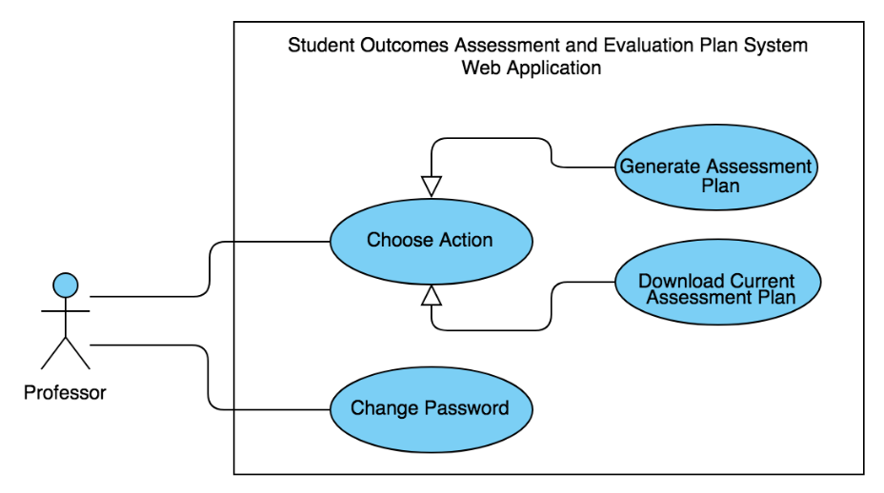

**Figure 1.** Professor Use Cases

*Note: Before this use case can be initiated, the user must first login for the system to determine whether he/she is a professor or the admin. In the case that the user is a Professor, the system will proceed with the steps below.*

**Use Case:** Choose Action

**Brief Description:** The Professor chooses an action, whether to generate an assessment plan or download the current data available.

**Initial Step-by-Step Description:**

1. The Professor selects *“Choose Action”.*
2. The system presents a choice whether to generate assessment plan or download current assessment plan.
3. The Professor chooses to generate or download.
4. If the Professor is to generate an assessment plan, he/she will be asked to input the necessary information to do so; else, the system allows the Professor to download the current assessment plan available from the database.
5. The Professor imports the necessary excel files containing the students’ grades per course after which edits or fills in the information required such as the starting quarter and school year then submits the form.
6. The system imports the necessary excel files from each course, containing specified assessment tools, and computes for the students’ average ratings per quarter and school year.
7. The system will then process and generate the excel file that contains the assessment plan then updates the database.

**Use Case:** Change Password

**Brief Description:** The Professor changes account password.

**Initial Step-by-Step Description:**

1. The Professor selects *“Change Password”.*
2. The system displays the *“Change Password*” window.
3. If the Professor is to change the current account password, he/she will be asked to input the necessary information to do so.
4. The Professor edits or fills in the information required then submits the form.
5. The system then saves changes and goes back to the initially opened window.
6. **Administrator Use Case**

The Administrator has the following set of use cases:

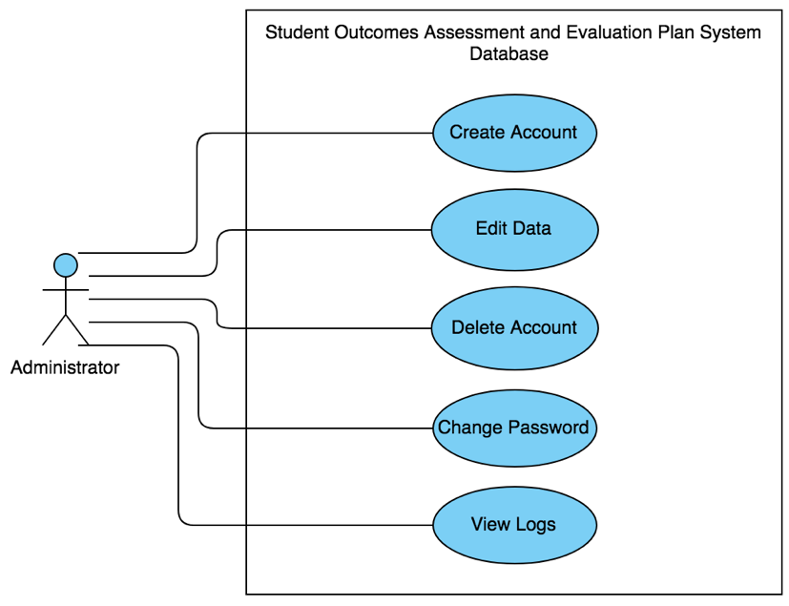

**Figure 2.** Administrator Use Cases

*Note: Before this use case can be initiated, the user must first login for the system to determine whether he/she is a professor or the admin. In the case that the user is the Administrator, the system will proceed with the steps below.*

**Use Case:** Create Account

**Brief Description:** The Admin creates a new faculty member account.

**Initial Step-by-Step Description:**

1. The Administrator selects *“Create Account”.*
2. The system displays a window with the necessary information to be filled out.
3. The Administrator fills out all the required data and submits the form.
4. The system verifies if all the required fields are filled out.
5. The system saves and updates the data in the database.

**Use Case:** Delete Account

**Brief Description:** The Professor deletes an existing faculty member’s account.

**Initial Step-by-Step Description:**

1. The Administrator selects *“Delete Account”.*
2. The system presents names of all the faculty members with an account.
3. The Administrator chooses which account is to be deleted.
4. The system verifies if the Administrator wants to delete the account.
5. If the Administrator confirms to delete the chosen account, the system proceeds to step 6; else, return to step 2.
6. The system then saves and updates the database.

**Use Case:** Edit Data

**Brief Description:** The Administrator edits information in the assessment plan.

**Initial Step-by-Step Description:**

1. The Administrator selects *“Edit Data”.*
2. The system displays the program’s assessment plan window.
3. The Administrator edits information such as performance indicators, student outcomes, and the like.
4. The system verifies if the Administrator wants to edit the information.
5. If the Administrator confirms to edit the information, the system proceeds to step 6; else, return to step 2.
6. The system then saves and updates the database.

**Use Case:** Change Password

**Brief Description:** The Administrator edits changes password.

**Initial Step-by-Step Description:**

1. The Administrator selects *“Change Password”.*
2. The system displays the *“Change Password*” window.
3. If the Administrator is to change the current account password, he/she will be asked to input the necessary information to do so.
4. The Administrator edits or fills in the information required then submits the form.
5. The system then saves changes and goes back to the initially opened window.

**Use Case:** View Logs

**Brief Description:** The Administrator displays all the processes done by the users when generating an assessment plan.

**Initial Step-by-Step Description:**

1. The Administrator selects *“View Logs”.*
2. The system displays the *“View Logs*” window.
3. From the *“View Logs”* window, the system displays all the processes executed by users when generating an assessment plan. The filenames are formatted as: “*AssessmentPlan_accountID_processID”* to distinguish which and whose log is it.
4. The Admin then exits the window.